Unsupervised learning -1

Clustering 2D points
From the scatter plot of the previous exercise, you saw that the points seem to separate into 3 clusters. You'll now create a KMeans model to find 3 clusters, and fit it to the data points from the previous exercise. After the model has been fit, you'll obtain the cluster labels for some new points using the .predict() method.
You are given the array points from the previous exercise, and also an array new_points.

Instructions
100xp

Instructions
100xp
- Import KMeans from sklearn.cluster.
- Using KMeans(), create a KMeans instance called model to find 3 clusters. To specify the number of clusters, use the n_clusters keyword argument.
- Use the .fit() method of model to fit the model to the array of points points.
- Use the .predict() method of model to predict the cluster labels of new_points, assigning the result to labels.
- Hit 'Submit Answer' to see the cluster labels of new_points

SOLUTION>
# Import KMeans
from sklearn.cluster import KMeans

# Create a KMeans instance with 3 clusters: model
model = KMeans(n_clusters = 3)

# Fit model to points
model.fit(points)

# Determine the cluster labels of new_points: labels
labels = model.predict(new_points)

# Print cluster labels of new_points
print(labels)
>>>>>>>>>>>>>>>>>>>>>>>>>>>>>>>>>>>>>>>>>>>>>>>>>>>>>>>>>>>>>>>>

Clustering

Unsupervised learning
- Unsupervised learning finds patterns in data
- E.g. clustering customers by their purchases
- Compressing the data using purchase patterns (dimension reduction)

Supervised vs unsupervised learning
- Supervised vs unsupervised learning
  - E.g. classify tumors as benign or cancerous (labels)
- Unsupervised learning finds pa!erns in data
  - ... but without a specific prediction task in mind

Arrays, features & samples
- 2D NumPy array
  - Columns are measurements (the features)
  - Rows represent iris plants (the samples)

k-means clustering
- k-means clustering
  - Number of clusters must be specified
    - Implemented in sklearn ("scikit-learn")
import pandas as pd
import numpy as np

from sklearn import datasets
import matplotlib.pyplot as plt
from mpl_toolkits.mplot3d import Axes3D
from sklearn.decomposition import PCA

%matplotlib inline

You are given an array points of size 300x2, where each row gives the (x, y) co-ordinates of a point on a map. Make a scatter plot of these points, and use the scatter plot to guess how many clusters there are.
from data import points, new_points
print points.shape, new_points.shape
(300, 2) (300, 2)
plt.figure(figsize=(6,8))

plt.subplot(2,1,1)
plt.scatter(points[:,0], points[:,1], alpha=.6, c='r')
plt.xlim([-3,3])

plt.subplot(2,1,2)
plt.scatter(new_points[:,0], new_points[:,1], alpha=.6, c='g')
<matplotlib.collections.PathCollection at 0x7f18dca222d0>
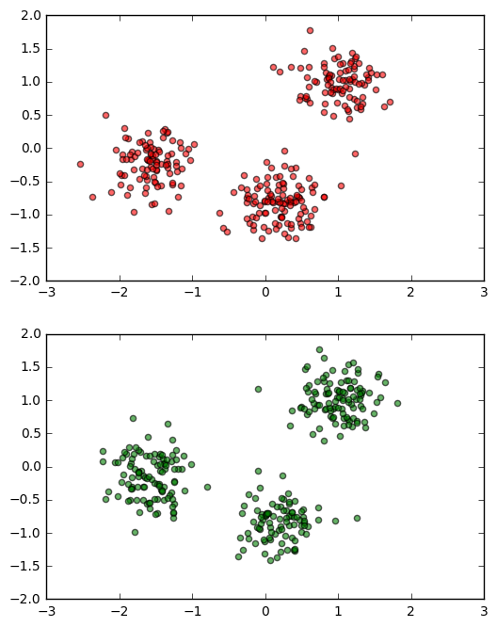

Clustering 2D points
- the points seem to separate into 3 clusters
  - create a KMeans model to find 3 clusters, and fit it to the data points
    - After the model has been fit, you'll obtain the cluster labels for some new points using the .predict() method.
# Import KMeans
from sklearn.cluster import KMeans

# Create a KMeans instance with 3 clusters: model
model = KMeans(n_clusters=3)

# Fit model to points
model.fit(points)

# Determine the cluster labels of new_points: labels
labels = model.predict(new_points)

# Print cluster labels of new_points
print(labels)
[2 1 0 2 1 2 1 1 1 0 2 1 1 0 0 1 0 0 1 1 0 1 2 1 2 0 1 0 0 2 2 1 1 1 0 2 1
1 2 1 0 2 2 0 2 1 0 0 1 1 1 1 0 0 2 2 0 0 0 2 2 1 1 1 2 1 0 1 2 0 2 2 2 1
2 0 0 2 1 0 2 0 2 1 0 1 0 2 1 1 1 2 1 1 2 0 0 0 0 2 1 2 0 0 2 2 1 2 0 0 2
0 0 0 1 1 1 1 0 0 1 2 1 0 1 2 0 1 0 0 1 0 1 0 2 1 2 2 1 0 2 1 2 2 0 1 1 2
0 2 0 1 2 0 0 2 0 1 1 0 1 0 0 1 1 2 1 1 0 2 0 2 2 1 2 1 1 2 2 0 2 2 2 0 1
1 2 0 2 0 0 1 1 1 2 1 1 1 0 0 2 1 2 2 2 0 1 1 1 1 1 1 0 0 1 0 0 0 0 1 0 0
1 1 2 0 2 2 0 2 0 2 0 1 1 0 1 1 1 0 2 2 0 1 1 0 1 0 0 1 0 0 2 0 2 2 2 1 0
0 0 2 1 2 0 2 0 0 1 2 2 2 0 1 1 1 2 1 0 0 1 2 2 0 2 2 0 2 1 2 0 0 0 0 1 0
0 1 1 2]

Inspect your clustering
- Let's now inspect the clustering you performed in the previous exercise!
  - A solution to the previous exercise has already run, so new_points is an array of points and labels is the array of their cluster labels.

examine the results
- color label by classification
model.cluster_centers_
array([[-1.57568905, -0.22531944],
[ 1.01378685, 0.98288627],
[ 0.18034887, -0.81701955]])
plt.figure(figsize=(8,5))

# Assign the columns of new_points: xs and ys
xs = new_points[:,0]
ys = new_points[:,1]

# Make a scatter plot of xs and ys, using labels to define the colors
plt.scatter(xs, ys, c=labels, alpha=0.5)

# Assign the cluster centers: centroids
centroids = model.cluster_centers_

# Assign the columns of centroids: centroids_x, centroids_y
centroids_x = centroids[:,0]
centroids_y = centroids[:,1]

# Make a scatter plot of centroids_x and centroids_y
plt.scatter(centroids_x, centroids_y, marker='D', s=50)
plt.show()
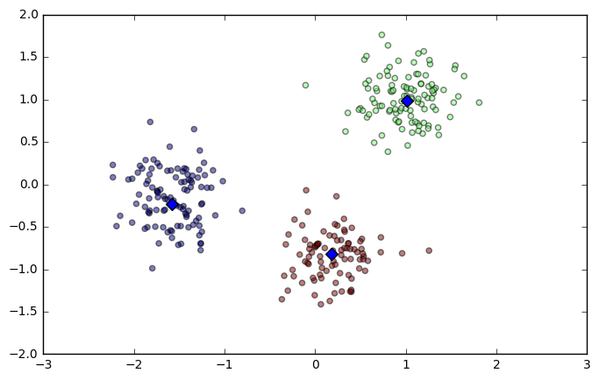

Iris: clusters vs species
- k-means found 3 clusters amongst the iris samples
  - k-means found 3 clusters amongst the iris samples

Iris dataset
- Measurements of many iris plants
  - 3 species of iris: setosa, versicolor, virginica
    - Petal length, petal width, sepal length, sepal width (the features of the dataset)
- Iris data is 4-dimensional
  - Dimension = number of features
    - Dimension too high to visualize!
      - ... but unsupervised learning gives insight
from sklearn import datasets

iris = datasets.load_iris()
print type(iris.data)
iris.data.shape
<type 'numpy.ndarray'>
(150, 4)

build a DataFrame for iris dataset from np ndarray
df = pd.DataFrame(iris.data, columns=iris.feature_names)
df['target']=iris.target

print iris.target_names
df['species'] = df['target'].map({0:iris.target_names[0],1:iris.target_names[1],2:iris.target_names[2]})
df.head()
['setosa' 'versicolor' 'virginica']
 | sepal length (cm) | sepal width (cm) | petal length (cm) | petal width (cm) | target | species
0 | 5.1 | 3.5 | 1.4 | 0.2 | 0 | setosa
1 | 4.9 | 3.0 | 1.4 | 0.2 | 0 | setosa
2 | 4.7 | 3.2 | 1.3 | 0.2 | 0 | setosa
3 | 4.6 | 3.1 | 1.5 | 0.2 | 0 | setosa
4 | 5.0 | 3.6 | 1.4 | 0.2 | 0 | setosa

make samples for clustering, remove labels
samples = df.iloc[:,:4]
samples.head()
 | sepal length (cm) | sepal width (cm) | petal length (cm) | petal width (cm)
0 | 5.1 | 3.5 | 1.4 | 0.2
1 | 4.9 | 3.0 | 1.4 | 0.2
2 | 4.7 | 3.2 | 1.3 | 0.2
3 | 4.6 | 3.1 | 1.5 | 0.2
4 | 5.0 | 3.6 | 1.4 | 0.2
from sklearn.cluster import KMeans

model2 = KMeans(n_clusters=3)
model.fit(samples)
KMeans(algorithm='auto', copy_x=True, init='k-means++', max_iter=300,
n_clusters=3, n_init=10, n_jobs=1, precompute_distances='auto',
random_state=None, tol=0.0001, verbose=0)
labels2 = model.predict(samples)
labels2
array([1, 1, 1, 1, 1, 1, 1, 1, 1, 1, 1, 1, 1, 1, 1, 1, 1, 1, 1, 1, 1, 1, 1,
1, 1, 1, 1, 1, 1, 1, 1, 1, 1, 1, 1, 1, 1, 1, 1, 1, 1, 1, 1, 1, 1, 1,
1, 1, 1, 1, 2, 2, 0, 2, 2, 2, 2, 2, 2, 2, 2, 2, 2, 2, 2, 2, 2, 2, 2,
2, 2, 2, 2, 2, 2, 2, 2, 0, 2, 2, 2, 2, 2, 2, 2, 2, 2, 2, 2, 2, 2, 2,
2, 2, 2, 2, 2, 2, 2, 2, 0, 2, 0, 0, 0, 0, 2, 0, 0, 0, 0, 0, 0, 2, 2,
0, 0, 0, 0, 2, 0, 2, 0, 2, 0, 0, 2, 2, 0, 0, 0, 0, 0, 2, 0, 0, 0, 0,
2, 0, 0, 0, 2, 0, 0, 0, 2, 0, 0, 2], dtype=int32)

Cluster labels for new samples
- New samples can be assigned to existing clusters
- k-means remembers the mean of each cluster (the "centroids")
- Finds the nearest centroid to each new sample

Scatter plots
- Scatter plot of sepal length vs petal length
- Each point represents an iris sample
- Color points by cluster labels
- PyPlot (matplotlib.pyplot)
plt.scatter(samples.iloc[:,0], samples.iloc[:,1], c=labels2, alpha = .7)
<matplotlib.collections.PathCollection at 0x7f18dc4d4d10>
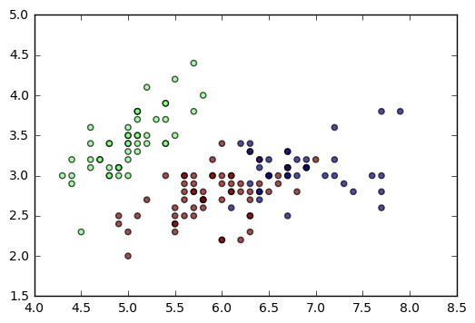

Evaluating a clustering
- Can check correspondence with e.g. iris species
  - … but what if there are no species to check against?
- Measure quality of a clustering
- Informs choice of how many clusters to look for

Cross tabulation with pandas
- Clusters vs species is a "cross-tabulation"
- Use the pandas library
- Given the species of each sample as a list species
pd.crosstab(df['target'], df['species'])
species | setosa | versicolor | virginica
target
0 | 50 | 0 | 0
1 | 0 | 50 | 0
2 | 0 | 0 | 50

train test split
- redo a clustering
from sklearn.model_selection import train_test_split

x_train, x_test, y_train, y_test = train_test_split(df.iloc[:,:4],df.species, test_size = .33, random_state=7)
print x_train.shape, x_test.shape, y_train.shape, y_test.shape
x_train.head(3)
(100, 4) (50, 4) (100,) (50,)
 | sepal length (cm) | sepal width (cm) | petal length (cm) | petal width (cm)
3 | 4.6 | 3.1 | 1.5 | 0.2
39 | 5.1 | 3.4 | 1.5 | 0.2
117 | 7.7 | 3.8 | 6.7 | 2.2

try a little bit supervised learning
from sklearn.neighbors import KNeighborsClassifier

model = KNeighborsClassifier()

# Fit model to points
model.fit(x_train,y_train)

# Determine the cluster labels of new_points: labels
labels = model.predict(x_test)

# Print cluster labels of new_points
print(labels)
['virginica' 'versicolor' 'setosa' 'versicolor' 'versicolor' 'setosa'
'versicolor' 'versicolor' 'setosa' 'versicolor' 'virginica' 'versicolor'
'setosa' 'virginica' 'setosa' 'versicolor' 'virginica' 'virginica'
'setosa' 'setosa' 'versicolor' 'virginica' 'versicolor' 'versicolor'
'virginica' 'versicolor' 'versicolor' 'versicolor' 'virginica' 'virginica'
'virginica' 'versicolor' 'setosa' 'virginica' 'versicolor' 'setosa'
'setosa' 'setosa' 'setosa' 'virginica' 'virginica' 'versicolor'
'virginica' 'virginica' 'versicolor' 'setosa' 'versicolor' 'versicolor'
'virginica' 'setosa']
pd.crosstab(labels, y_test)
species | setosa | versicolor | virginica
row_0
setosa | 14 | 0 | 0
versicolor | 0 | 17 | 3
virginica | 0 | 1 | 15

unsupervised learning

kmeans
# Import KMeans
from sklearn.cluster import KMeans

# Create a KMeans instance with 3 clusters: model
model = KMeans(n_clusters=3)

# Fit model to points
model.fit(df.iloc[:,:4])

# Determine the cluster labels of new_points: labels
labels = model.predict(df.iloc[:,:4])

# Print cluster labels of new_points
print(labels)
[1 1 1 1 1 1 1 1 1 1 1 1 1 1 1 1 1 1 1 1 1 1 1 1 1 1 1 1 1 1 1 1 1 1 1 1 1
1 1 1 1 1 1 1 1 1 1 1 1 1 2 2 0 2 2 2 2 2 2 2 2 2 2 2 2 2 2 2 2 2 2 2 2 2
2 2 2 0 2 2 2 2 2 2 2 2 2 2 2 2 2 2 2 2 2 2 2 2 2 2 0 2 0 0 0 0 2 0 0 0 0
0 0 2 2 0 0 0 0 2 0 2 0 2 0 0 2 2 0 0 0 0 0 2 0 0 0 0 2 0 0 0 2 0 0 0 2 0
0 2]

Measuring clustering quality
- Using only samples and their cluster labels
- A good clustering has tight clusters
- ... and samples in each cluster bunched together
pd.crosstab(labels, df.species)
species | setosa | versicolor | virginica
row_0
0 | 0 | 2 | 36
1 | 50 | 0 | 0
2 | 0 | 48 | 14

Inertia measures clustering quality
- Measures how spread out the clusters are (lower is better)
- Distance from each sample to centroid of its cluster
- After fit(), available as attribute inertia_
- k-means attempts to minimize the inertia when choosing clusters
print(model.inertia_)
78.9408414261

PCA , decompress to 2 dimension to examine the clustering
from sklearn.decomposition import PCA
pca = PCA(2)
pca
PCA(copy=True, iterated_power='auto', n_components=2, random_state=None,
svd_solver='auto', tol=0.0, whiten=False)
df_pca = pca.fit_transform(df.iloc[:,:4])
df_pca.shape
(150, 2)
plt.scatter(df_pca[:,0], df_pca[:,1],c = labels)
<matplotlib.collections.PathCollection at 0x7f18d8da2690>
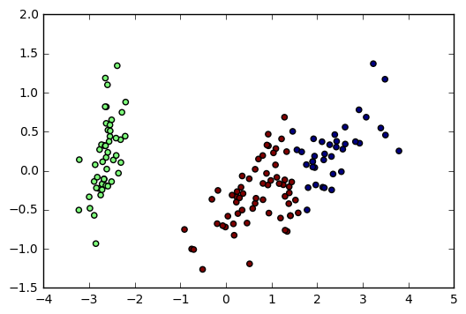

The number of clusters
- Clusterings of the iris dataset with different numbers of clusters
- More clusters means lower inertia
- What is the best number of clusters?

How many clusters to choose?
- good clustering has tight clusters (so low inertia)
- ... but not too many clusters!
- Choose an "elbow" in the inertia plot
- Where inertia begins to decrease more slowly
- E.g. for iris dataset, 3 is a good choice
model.score(df.iloc[:,:4])
-78.940841426145937

How many clusters of grain?
- Append the value of the inertia_ attribute of model to the list inertias.
ks = range(1, 6)
inertias = []

for k in ks:
# Create a KMeans instance with k clusters: model
model = KMeans(n_clusters=k)

# Fit model to samples
model.fit(df.iloc[:,:4])

# Append the inertia to the list of inertias
inertias.append(model.inertia_)

# Plot ks vs inertias
plt.plot(ks, inertias, '-o')
plt.xlabel('number of clusters, k')
plt.ylabel('inertia')
plt.xticks(ks)
plt.show()
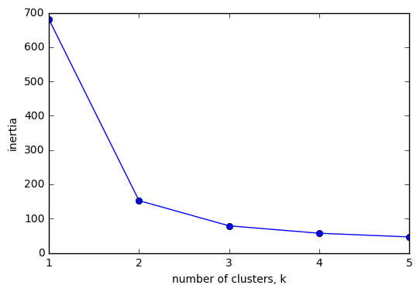
df.describe()
 | sepal length (cm) | sepal width (cm) | petal length (cm) | petal width (cm) | target
count | 150.000000 | 150.000000 | 150.000000 | 150.000000 | 150.000000
mean | 5.843333 | 3.054000 | 3.758667 | 1.198667 | 1.000000
std | 0.828066 | 0.433594 | 1.764420 | 0.763161 | 0.819232
min | 4.300000 | 2.000000 | 1.000000 | 0.100000 | 0.000000
25% | 5.100000 | 2.800000 | 1.600000 | 0.300000 | 0.000000
50% | 5.800000 | 3.000000 | 4.350000 | 1.300000 | 1.000000
75% | 6.400000 | 3.300000 | 5.100000 | 1.800000 | 2.000000
max | 7.900000 | 4.400000 | 6.900000 | 2.500000 | 2.000000
df.var()
sepal length (cm) 0.685694
sepal width (cm) 0.188004
petal length (cm) 3.113179
petal width (cm) 0.582414
target 0.671141
dtype: float64
import numpy as np
np.sqrt(df.var())
sepal length (cm) 0.828066
sepal width (cm) 0.433594
petal length (cm) 1.764420
petal width (cm) 0.763161
target 0.819232
dtype: float64

Transforming features for better clusterings

some models like KMean are highly influced by the feature's diff variance
- To make all the feature (columns) have equal variance, which is 0,1
  - use standardscaler
    - StandardScaler
      - from sklearn.preprocessing import StandardScaler

StandardScaler

pipline

Piedmont wines dataset
- https://archive.ics.uci.edu/ml/datasets/Wine
# Perform the necessary imports
from sklearn.pipeline import make_pipeline
from sklearn.preprocessing import StandardScaler
from sklearn.cluster import KMeans

# Create scaler: scaler
scaler = StandardScaler()

# Create KMeans instance: kmeans
kmeans = KMeans(n_clusters=3)

# Create pipeline: pipeline
pipeline = make_pipeline(scaler, kmeans)
names = '''Alcohol , Malic acid , Ash , Alcalinity of ash , Magnesium ,
Total phenols , Flavanoids , Nonflavanoid phenols , Proanthocyanins ,Color intensity ,Hue ,OD280/OD315 of diluted wines ,Proline '''

names = names.split(',')
wine = pd.read_csv('https://archive.ics.uci.edu/ml/machine-learning-databases/wine/wine.data',names = names)
wine.info()
<class 'pandas.core.frame.DataFrame'>
Int64Index: 178 entries, 1 to 3
Data columns (total 13 columns):
Alcohol 178 non-null float64
Malic acid 178 non-null float64
Ash 178 non-null float64
Alcalinity of ash 178 non-null float64
Magnesium 178 non-null int64

Total phenols 178 non-null float64
Flavanoids 178 non-null float64
Nonflavanoid phenols 178 non-null float64
Proanthocyanins 178 non-null float64
Color intensity 178 non-null float64
Hue 178 non-null float64
OD280/OD315 of diluted wines 178 non-null float64
Proline 178 non-null int64
dtypes: float64(11), int64(2)
memory usage: 19.5 KB

feature variance
wine.var()
Alcohol 0.659062
Malic acid 1.248015
Ash 0.075265
Alcalinity of ash 11.152686
Magnesium 203.989335
\nTotal phenols 0.391690
Flavanoids 0.997719
Nonflavanoid phenols 0.015489
Proanthocyanins 0.327595
Color intensity 5.374449
Hue 0.052245
OD280/OD315 of diluted wines 0.504086
Proline 99166.717355
dtype: float64
classes = [59,71,48]
wine = wine.reset_index()
del wine['index']

add labels
wine['class'] = ['Barolo' for i in range(59)]+ ['Grignolino' for i in range(71)] + ['Barbera' for i in range(48)]
wine['class'].value_counts()
Grignolino 71
Barolo 59
Barbera 48
Name: class, dtype: int64

Clustering the wines
from sklearn.cluster import KMeans
model = KMeans(n_clusters=3)
labels = model.fit_predict(wine.iloc[:,:-1])
pd.crosstab(labels, wine['class'])
class | Barbera | Barolo | Grignolino
row_0
0 | 19 | 0 | 50
1 | 0 | 46 | 1
2 | 29 | 13 | 20

accuracy sucks due to high variances among features
- Variance of a feature measures spread of its values
wine.var()
Alcohol 0.659062
Malic acid 1.248015
Ash 0.075265
Alcalinity of ash 11.152686
Magnesium 203.989335
\nTotal phenols 0.391690
Flavanoids 0.997719
Nonflavanoid phenols 0.015489
Proanthocyanins 0.327595
Color intensity 5.374449
Hue 0.052245
OD280/OD315 of diluted wines 0.504086
Proline 99166.717355
dtype: float64

Feature variances

relationship between the last 2 features
plt.scatter(wine.iloc[:,-3], wine.iloc[:,-2],
c= wine.iloc[:,-1].map({'Barbera':'r', 'Barolo':'g', 'Grignolino':'b'}),
alpha=.7)

plt.axis('equal')
(1.0, 4.5, 200.0, 1800.0)
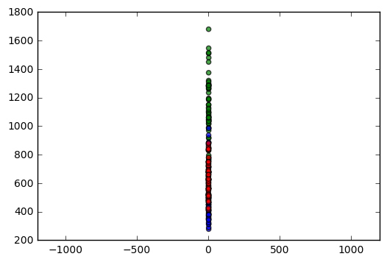

after StandardScaler
from sklearn.preprocessing import StandardScaler
scaler = StandardScaler()
wine.iloc[:,:-1] = scaler.fit_transform(wine.iloc[:,:-1])

plt.scatter(wine.iloc[:,-3], wine.iloc[:,-2],
c= wine.iloc[:,-1].map({'Barbera':'r', 'Barolo':'g', 'Grignolino':'b'}),
alpha=.7)

plt.axis('equal')
(-3.0, 3.0, -2.0, 4.0)
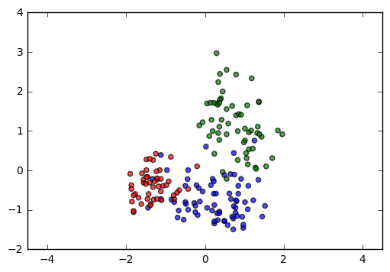

sklearn StandardScaler
In [1]: from sklearn.preprocessing import StandardScaler
In [2]: scaler = StandardScaler()
In [3]: scaler.fit(samples)
Out[3]: StandardScaler(copy=True, with_mean=True, with_std=True)
In [4]: samples_scaled = scaler.transform(samples)

Similar methods
● StandardScaler and KMeans have similar methods
● Use fit() / transform() with StandardScaler
● Use fit() / predict() with KMeans

StandardScaler, then KMeans
● Need to perform two steps: StandardScaler, then KMeans
● Use sklearn pipeline to combine multiple steps
● Data flows from one step into the next

Pipelines combine multiple steps
from sklearn.preprocessing import StandardScaler
from sklearn.cluster import KMeans

scaler = StandardScaler()
kmeans = KMeans(n_clusters=3)

from sklearn.pipeline import make_pipeline
pipe = make_pipeline(scaler, kmeans)
pipe
Pipeline(steps=[('standardscaler', StandardScaler(copy=True, with_mean=True, with_std=True)), ('kmeans', KMeans(algorithm='auto', copy_x=True, init='k-means++', max_iter=300,
n_clusters=3, n_init=10, n_jobs=1, precompute_distances='auto',
random_state=None, tol=0.0001, verbose=0))])
pipe.fit(wine.iloc[:,:-1])
Pipeline(steps=[('standardscaler', StandardScaler(copy=True, with_mean=True, with_std=True)), ('kmeans', KMeans(algorithm='auto', copy_x=True, init='k-means++', max_iter=300,
n_clusters=3, n_init=10, n_jobs=1, precompute_distances='auto',
random_state=None, tol=0.0001, verbose=0))])
labels = pipe.predict(wine.iloc[:,:-1])
labels
array([2, 2, 2, 2, 2, 2, 2, 2, 2, 2, 2, 2, 2, 2, 2, 2, 2, 2, 2, 2, 2, 2, 2,
2, 2, 2, 2, 2, 2, 2, 2, 2, 2, 2, 2, 2, 2, 2, 2, 2, 2, 2, 2, 2, 2, 2,
2, 2, 2, 2, 2, 2, 2, 2, 2, 2, 2, 2, 2, 1, 1, 0, 1, 1, 1, 1, 1, 1, 1,
1, 1, 1, 1, 2, 1, 1, 1, 1, 1, 1, 1, 1, 1, 0, 1, 1, 1, 1, 1, 1, 1, 1,
1, 1, 1, 2, 1, 1, 1, 1, 1, 1, 1, 1, 1, 1, 1, 1, 1, 1, 1, 1, 1, 1, 1,
1, 1, 1, 0, 1, 1, 2, 1, 1, 1, 1, 1, 1, 1, 1, 0, 0, 0, 0, 0, 0, 0, 0,
0, 0, 0, 0, 0, 0, 0, 0, 0, 0, 0, 0, 0, 0, 0, 0, 0, 0, 0, 0, 0, 0, 0,
0, 0, 0, 0, 0, 0, 0, 0, 0, 0, 0, 0, 0, 0, 0, 0, 0], dtype=int32)

huge accurancy improvement after standardscaler
pd.crosstab(labels, wine['class'])
class | Barbera | Barolo | Grignolino
row_0
0 | 48 | 0 | 3
1 | 0 | 0 | 65
2 | 0 | 59 | 3

sklearn preprocessing steps
● StandardScaler is a "preprocessing" step
● MaxAbsScaler and Normalizer are other examples
Note that Normalizer() is different to StandardScaler(), which you used in the previous exercise. While StandardScaler() standardizes features (such as the features of the fish data from the previous exercise) by removing the mean and scaling to unit variance, Normalizer() rescales each sample - here, each company's stock price - independently of the other.

>>>>>>>>>>>>>>>>>>>>>>>>>>>>>>>>>>>>>>>>>>>>>>>>>>>>>>>>>>>>>>>>>>>>>>>

Evaluating the grain clustering
In the previous exercise, you observed from the inertia plot that 3 is a good number of clusters for the grain data. In fact, the grain samples come from a mix of 3 different grain varieties: "Kama", "Rosa" and "Canadian". In this exercise, cluster the grain samples into three clusters, and compare the clusters to the grain varieties using a cross-tabulation.
You have the array samples of grain samples, and a list varieties giving the grain variety for each sample. Pandas (pd) and KMeans have already been imported for you.

Instructions
100xp
- Create a KMeans model called model with 3 clusters.
- Use the .fit_predict() method of model to fit it to samples and derive the cluster labels. Using .fit_predict() is the same as using .fit() followed by .predict().
- Create a DataFrame df with two columns named 'labels' and 'varieties', using labels and varieties, respectively, for the column values. This has been done for you.
- Use the pd.crosstab() function on df['labels'] and df['varieties'] to count the number of times each grain variety coincides with each cluster label. Assign the result to ct.
- Hit 'Submit Answer' to see the cross-tabulation!
Take Hint (-30xp)
SOLUTION.
# Create a KMeans model with 3 clusters: model
model = KMeans(n_clusters=3)

# Use fit_predict to fit model and obtain cluster labels: labels
labels = model.fit_predict(samples)

# Create a DataFrame with labels and varieties as columns: df
df = pd.DataFrame({'labels': labels, 'varieties': varieties})

# Create crosstab: ct
ct = pd.crosstab(df['labels'], df['varieties'])

# Display ct
print(ct)

>>>>>>>>>>>>>>>>>>>>>>>>>>>>>>>>>>>>>>>>>>>>>>>>>>>>>>>>>>...

Scaling fish data for clustering
You are given an array samples giving measurements of fish. Each row represents an individual fish. The measurements, such as weight in grams, length in centimeters, and the percentage ratio of height to length, have very different scales. In order to cluster this data effectively, you'll need to standardize these features first. In this exercise, you'll build a pipeline to standardize and cluster the data.
These fish measurement data were sourced from the Journal of Statistics Education.

Instructions
100xp
- Import:
  - make_pipeline from sklearn.pipeline.
  - StandardScaler from sklearn.preprocessing.
  - KMeans from sklearn.cluster.
- Create an instance of StandardScaler called scaler.
- Create an instance of KMeans with 4 clusters called kmeans.
- Create a pipeline called pipeline that chains scaler and kmeans. To do this, you just need to pass them in as arguments to make_pipeline().
SOLUTION
# Perform the necessary imports
from sklearn.pipeline import make_pipeline
from sklearn.preprocessing import StandardScaler
from sklearn.cluster import KMeans

# Create scaler: scaler
scaler = StandardScaler()

# Create KMeans instance: kmeans
kmeans = KMeans(n_clusters=4)

# Create pipeline: pipeline
pipeline = make_pipeline(scaler, kmeans)
>>>>>>>>>>>>>>>>>>>>>>>>>>>>>>>>>>>>>>>>>

Clustering the fish data
You'll now use your standardization and clustering pipeline from the previous exercise to cluster the fish by their measurements, and then create a cross-tabulation to compare the cluster labels with the fish species.
As before, samples is the 2D array of fish measurements. Your pipeline is available as pipeline, and the species of every fish sample is given by the list species.

Instructions
100xp

Instructions
100xp
- Import pandas as pd.
- Fit the pipeline to the fish measurements samples.
- Obtain the cluster labels for samples by using the .predict() method of pipeline.
- Using pd.DataFrame(), create a DataFrame df with two columns named 'labels' and 'species', using labels and species, respectively, for the column values.
- Using pd.crosstab(), create a cross-tabulation ct of df['labels'] and df['species'].
SOLUTIONS:
# Import pandas
import pandas as pd

# Fit the pipeline to samples

pipeline.fit(samples)
# Calculate the cluster labels: labels
labels = pipeline.predict(samples)

# Create a DataFrame with labels and species as columns: df
df = pd.DataFrame({'labels': labels,'species':species})

# Create crosstab: ct
ct = pd.crosstab(df['labels'], df['species'])

# Display ct
print(ct)

>>>>>>>>>>>>>>>>>>>>>>>>>>>>>>>>>>>>>>>>>>>>>>>>>>>>>>>>>>>>>>>>

Clustering stocks using KMeans
In this exercise, you'll cluster companies using their daily stock price movements (i.e. the dollar difference between the closing and opening prices for each trading day). You are given a NumPy array movements of daily price movements from 2010 to 2015 (obtained from Yahoo! Finance), where each row corresponds to a company, and each column corresponds to a trading day.
Some stocks are more expensive than others. To account for this, include a Normalizer at the beginning of your pipeline. The Normalizer will separately transform each company's stock price to a relative scale before the clustering begins.
Note that Normalizer() is different to StandardScaler(), which you used in the previous exercise. While StandardScaler() standardizes features (such as the features of the fish data from the previous exercise) by removing the mean and scaling to unit variance, Normalizer() rescales each sample - here, each company's stock price - independently of the other.
KMeans and make_pipeline have already been imported for you.

Instructions
100xp

Instructions
100xp
- Import Normalizer from sklearn.preprocessing.
- Create an instance of Normalizer called normalizer.
- Create an instance of KMeans called kmeans with 10 clusters.
- Using make_pipeline(), create a pipeline called pipeline that chains normalizer and kmeans.
- Fit the pipeline to the movements array.
SOLUTIONS>>

# Import Normalizer
from sklearn.preprocessing import Normalizer

# Create a normalizer: normalizer
normalizer = Normalizer()

# Create a KMeans model with 10 clusters: kmeans
kmeans = KMeans(n_clusters=10)

# Make a pipeline chaining normalizer and kmeans: pipeline
pipeline = make_pipeline(normalizer, kmeans)

# Fit pipeline to the daily price movements
pipeline.fit(movements)

>>>>>>>>>>>>>>>>>>>>>>>>>>>>>>>>>>>>>>>>>>>>>>>>>>>>>>>>>>>>>>>>>>>>>>

Which stocks move together?
In the previous exercise, you clustered companies by their daily stock price movements. So which company have stock prices that tend to change in the same way? You'll now inspect the cluster labels from your clustering to find out.
Your solution to the previous exercise has already been run. Recall that you constructed a Pipeline pipeline containing a KMeans model and fit it to the NumPy array movements of daily stock movements. In addition, a list companies of the company names is available.

Instructions
70xp
- Import pandas as pd.
- Use the .predict() method of the pipeline to predict the labels for movements.
- Align the cluster labels with the list of company names companies by creating a DataFrame df with labels and companies as columns. This has been done for you.
- Use the .sort_values() method of df to sort the DataFrame by the 'labels' column, and print the result.
- Hit 'Submit Answer' and take a moment to see which companies are together in each cluster!
SOLUTIONS:
# Import pandas
import pandas as pd

# Predict the cluster labels: labels
labels = pipeline.predict(movements)

# Create a DataFrame aligning labels and companies: df
df = pd.DataFrame({'labels': labels, 'companies': companies})

# Display df sorted by cluster label
print(df.sort_values('labels'))

